Process Report

Digital Circuit Tool

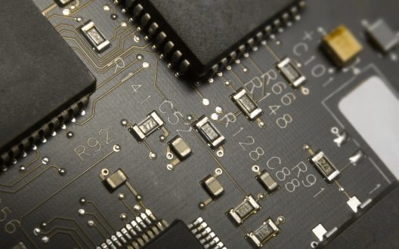

Fontys, Eindhoven, the Netherlands

**Principal Investigator:**

Bert van Gestel

**Team members:**

Todor Kosev

Tsvetomir Yotov

Rimgaudas Tamulevicius

Vytautas Skinkys

**Duration:**

September 2013 – January 2013 (5 months)

Group: C

Date: 20 October 2014,

Location: Fontys University, Room 4.24d, Eindhoven, Nederland

Table of Contents

1 Introduction 3

2 Schedule 4

3 Individual Work 5

5 Team Work 5

6 Choices Made 7

7 Conclussion 8

Introduction

In this process report it is explained how our group tackled the project of Prop, both in individual work and also in group work. The purpose of this project was to apply the teamwork skills that we need to communicate with each other and also the knowledge that we gained from our first year of the university. Luckily we able to communicate enough and we did enjoy the project due to the understandings that we made with each other and the teacher. We were able to divide the project in to individual parts for every member .

Schedule

The project is meant to be finished before 20h January. The deliverables were divided in two parts:

* First part
  + Data-Base Design
  + C# Desgin
  + Website Design
* Second part
  + Data-Base Implementation
  + C# Implementation
  + Website Implementation

Individual work n Team work

C#

|  |  |
| --- | --- |
| **Task Name** | **Done by** |
| RFID Scanner | Tsvetomir |
| Connection to Database | Vytautas |
| Display Buttons with products and materials | Todor –Rimgaudas-Vytautas |
| Chech if ticket is payed | Tsvetomir |
| Change status of visitor | Todor |
| Check if the customer has unpayed orders | Tsvetomir |
| Recharge money balance | Todor |
| Place orders and orderlines in the database | Todor and Tsvetomir |
| Borrow materials and make unpayed orders | Vytautas |
| Assign clients to camping spots | Rimgaudas |
| Display the map and location of camping spots | Vytautas |
| Dispaly pie chart with number of visitors in event and out event | Rimgaudas |
| Display a histogram with total money and money spet. STATISTICS | Rimgaudas |
| Assign RDID to new clients | Vytautas |
|  |  |

**Team work**

1. Website implentation statical part like html and css.
2. Php fucntunality
3. Cleared some bugs together
4. Process report
5. Discussion about how everything should be done.

Choices Made n Problems

Choices Made

1. A client must always reserve a ticket.
2. A client can recharge only at the entaracne.
3. Fixed amount of money for all the items to be sold or borrowed

Conclusion

The entire project was useful for the team:

* combine the knowledge from different subject
* working as a group
* sharing tasks
* combining several components into 1
* weekly meetings with client
* real life project experience